**General Council of the University of Edinburgh**

**Saturday June 15th 2019 in the McEwan Hall, Edinburgh**

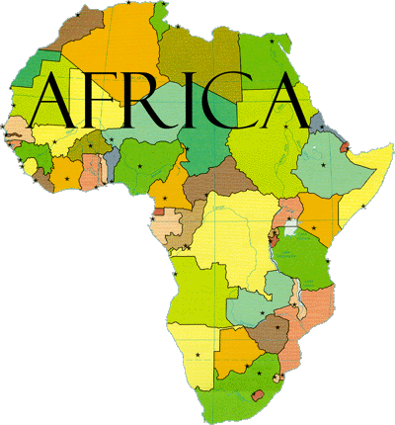

This event follows the statutory Half Yearly Meeting of the General Council in Foyer no. 4. This pack contains information about presenters and exhibitors included in the programme.

|  |  |
| --- | --- |
| 11.15 – 11.30am | **Introduction: The University of Edinburgh and Africa**  James Smith, Vice-Principal |
| 11.30 – 11.45am | **The Past** : UncoverEd  Henry Mitchell & Tom Cunningham |
| 11.50am – 12.40pm | **The Present**: progress, prospects and challenges   * Panel Discussion chaired by Tom Molony * Panel : Liz Grant, Francisca Mutapi and James Smith |
| 12.40pm | Participants move to main auditorium (piano playing) |
| 12.55 – 1.10pm | Ifeanyichukwu Ezinmadu introduced by Nick Rowland |
| 1.15 – 2.30pm | **Lunch and exhibitions:**   * A light buffet lunch with soft drinks, tea and coffee will be available in the main auditorium. * Exhibits and information reflecting a range of the University’s work in Africa will be on display. |
| 2.30 – 3.00pm | **Looking to the Future**  Derek MacLeod  Film & presentation about the Mastercard Scholarship programme  Barry Dwolatzky |
| 3.00pm | **Close** |

Exhibits will include: the work of TIBA – Tackling Infections to Benefit Africa; SEBI – Supporting Evidence Based Interventions for livestock; The Centre for Tropical Livestock Genetics and Health; Land management and the impact of global change on ecosystems; Irrigation and water purification; Global Health Academy East African Summer school; Gallery of photographs of African alumni – UncoverEd; Global Justice Academy photographic exhibition.

**\*\*Please note that this event will be filmed \*\***